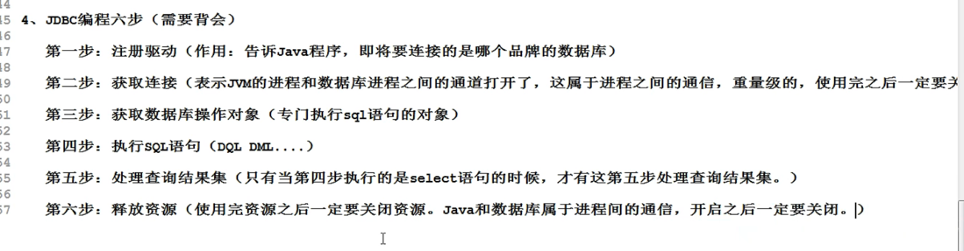

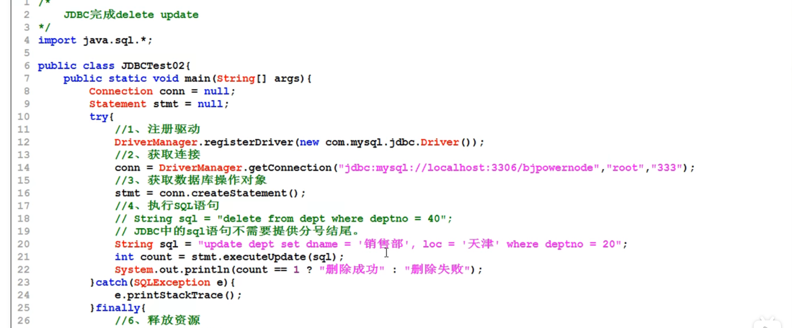

反射机制：

